Grade 7 Accelerated · Unit 6 · Lesson 3  Pythagorean Theorem  Independent Set 6.03 ANSWER KEY | Name  Date  Period

Six questions, on your own, in silence. Show the step that does the work.
1. A right triangle has legs of 12 m and 5 m. How long is the hypotenuse?
13 m
144 + 25 = 169 = 13².

2. A right triangle has legs of 3 ft and 8 ft. How long is the hypotenuse, exactly and to the nearest tenth?
√73 ft ≈ 8.5 ft
9 + 64 = 73.

3. A right triangle has a hypotenuse of 39 cm and one leg of 36 cm. How long is the other leg?
15 cm
1,521 − 1,296 = 225 = 15².

4. A right triangle has a hypotenuse of 11 inches and one leg of 4 inches. How long is the other leg, exactly and to the nearest tenth?
√105 in ≈ 10.2 in
121 − 16 = 105.

5. A right triangle has legs of 6 m and 11 m (drawn turned on its side on the paper). How long is its hypotenuse, to the nearest tenth?
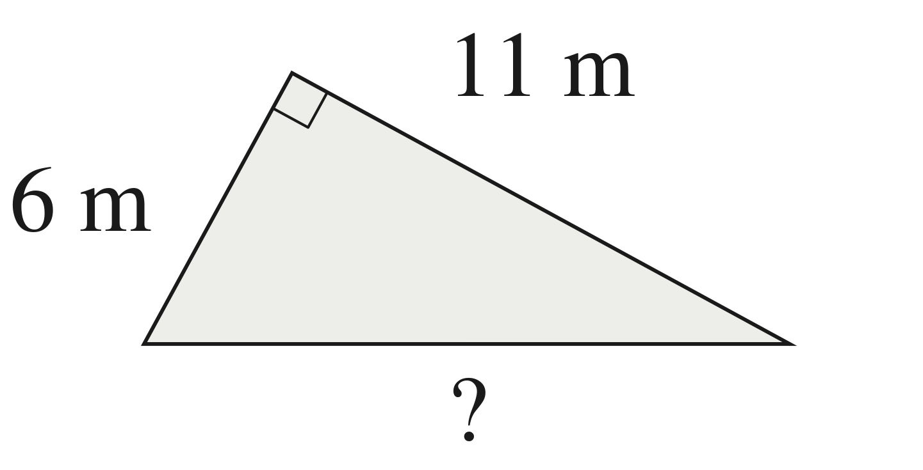
√157 m ≈ 12.5 m
36 + 121 = 157; c is across from the square corner.

6. A right triangle has a hypotenuse of 25 yd and one leg of 24 yd. The other leg is x. Write the equation that finds x, then find x.
24² + x² = 25²; x = 7 yd
625 − 576 = 49 = 7².

